*A project report on*

Cash Accounting Automation

&

ERP Migration

*Submitted in partial fulfillment for the award of the degree of*

**Bachelor of Technology**

In

**Electronics and Communication**

*by*

**Atri Sengupta**

**17BEC0173**



**SENSE**

(July 2021)

*A project report on*

Cash Accounting Automation

&

ERP Migration

*Submitted in partial fulfillment for the award of the degree of*

**Bachelor of Technology**

In

**Electronics and Communication**

*by*

**Atri Sengupta**

**17BEC0173**



**SENSE**

(July 2021)

# DECLARATION

I hereby declare that the thesis entitled “Cash Accounting Automation & ERP Migration” submitted by me, for the award of the degree of *Bachelor of Technology in Programme* to VIT is a record of bonafide work carried out by me under the supervision of Giuseppe Farago.

I further declare that the work reported in this thesis has not been submitted and will not be submitted, either in part or in full, for the award of any other degree or diploma in this institute or any other institute or university.

Place : Vellore Atri Sengupta

Date: 25 July 2021 Signature by the Candidate

**Internship completion certificate**

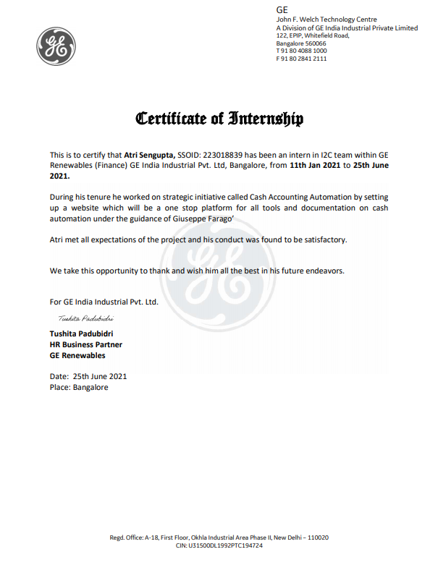

Date: 13th July 2020.

## CERTIFICATE BY THE EXTERNAL GUIDE

This is to certify that the project report entitled “Cash Accounting Automation &

ERP Migration**”** submitted by **Atri Sengupta (17BEC0173)** to Vellore Institute of Technology in partial fulfilment of the requirement for the award of the degree of B.Tech in Electronics and Communication is a record of bonafide work carried out by him under my guidance. The project fulfils the requirements as per the regulations of this Institute and in my opinion meets the necessary standards for submission. The contents of this report have not been submitted and will not be submitted either in part or in full, for the award of any other degree or diploma in this institute or any other institute or university.

Giuseppe Farago,

Sr Staff Technical Program Manager

REN-COES-DT Finance

Ge Renewable Energy.

# Abstract

Cash Accounting Automation is a strategic initiative with purpose of automating through different system solutions, the cash accounting process for strategic ERP. Cash Automation will help to improve process quality and reduces the related costs.

ERP migration project involves shift of Onshore Wind Mexico entity from CCL to RACES. This gives us the scope of bringing satellite initiatives in form of GECARS to a broader prospective.

# Acknowledgment

I would like to express my gratitude to all who directly or indirectly aided in completion of this project.

I would like to extend my gratitude towards my institution, Vellore Institute Of Technology, Vellore and its Chancellor Dr. G. Vishwanathan for the opportunity to pursue the final year internship and get an exposure to the industry and learn from skilled professionals.

I would also like to thank my HOD Prof. Prakasam P for the encouragement provided during the project. My gratitude also goes out to my internal guide at GE Renewable Energy, for his able and nurturing guidance and support throughout the duration of the internship.

Also, my sincere thanks goes to my team members for ensuring a growth conducive work environment.

I also thank my manager, and my mentor, for their continued support and guidance throughout my internship period. The completion of the projects done during the internship would not have been possible without their support and guidance.

Thank you.

Atri Sengupta

Signature of the Candid

**List of acronym**

|  |  |
| --- | --- |
| GECARS | GE Core Account Receivable System |
| FDL | Finance Data Lake |
| ERP | Enterprise Resource Planning |
| CAA | Cash Accounting Automation |
| GE | General Electric |
| SIT | System Integration Testing |
| UAT | User Integration Testing |



**Chapter 1**

**Introduction**

## 1.1 About the Company

**GE Renewable Energy** is a division of General Electric headquartered in Paris, France focusing on production of energy from renewable sources. Its portfolio of products includes wind (onshore and offshore), hydroelectric and solar (concentrated and photovoltaic) power generating solutions.

GE Renewable Energy was created in 2015, combining the wind power assets GE purchased from Alstom with those previously owned by GE and operated under the Power & Water divisionUpon the division's creation, the headquarters of GE Renewable Energy moved from Schenectady, New York to Paris, France, part of conditions for the Alstom purchase.

**1.2 Sub-Divisions**

**Wind**

Main article: GE Wind Energy

GE Wind Energy was formed out of the assets of Enron Wind purchased in 2002 and subsequently expanded with the purchase of ScanWind in 2009. GE Wind expanded into offshore wind energy with the purchase of Alstom's energy generation assets in 2015.

**Hydro**

The GE Hydro sub-division of GE Renewable energy is involved in hydroelectricity generation. This includes the design, manufacture, and installation of equipment for both gravity fed and pumped-storage power plants and as upgrades to existing hydroelectric plants.

GE Hydro has developed aerating turbines designed to increase the amount of oxygen in water passing through the turbines, to benefit the aquatic life downstream.



**Chapter 2**

**Cash Accounting Automation**

**2.1 PROBLEM STATEMENT**

Cash Accounting Automation is a strategic initiative with purpose of automating through different system solutions, the cash accounting process for strategic ERP. Cash Automation will help to improve process quality and reduces the related costs.

Current process of getting information on cash automation initiative was highly human dependent. This caused rework and inefficiency for both the business and project teams.

## OBJECTIVE

Objective of CAA is to automate the process of posting bank statement in ERP, Matching through cash application and reconciliation, all these processes which are taking place manually today. This will help reduce the repeated work and people can devote time to more value added work, at the same time reduce the service cost we provide to companies like GENPACT.

## RESPONSIBILITIES ASSIGNED

I contributed to the Cash Accounting Automation initiative by establishing a central repository in form of website which is now a one stop platform for all tools and documentation on cash automation. This helped to better communicate the initiative across the teams. Users can quicky access files and link to critical websites needed to carry out their business. As a result of this, cash management became more efficient and ultimately GE cash inflow got improved .

**2.1.3 TARGET CUSTOMERS**

When the website is fully functional a total of 70-80 people will be using it ranging from the Leadership group to operation team leaders to key users. A weekly unique head count of 20 users for the website can be considered as a success for the website.

* + 1. **BUSINESS OUTCOME**

If we take a conservative approach and consider that only 10 people will be using the website, then for a near zero investment we get a cost benefit of 8,333$ per year and a cycle time reduction of 360 hours per year. Thanks to this time saved, there will be quicker inflow of cash into GE of approximately 16M $.

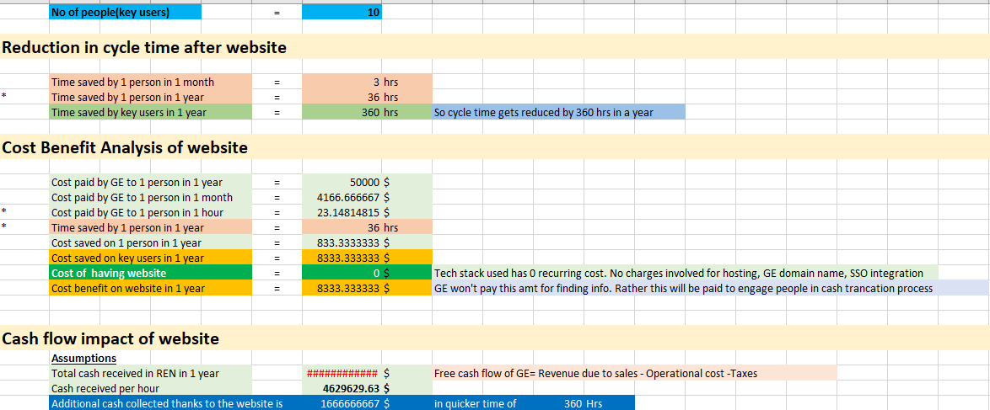

* + 1. **TECH STACK USED**

1. **WordPress** is the world’s most popular content management system. WordPress now powers 40% of all websites and controls a massive 40.0% of the known content management system market.

Very attractive and user-friendly websites can be made in quick time and with limited coding using **WordPress**. Makes maintenance easy even for functional teams without expertise in web development.

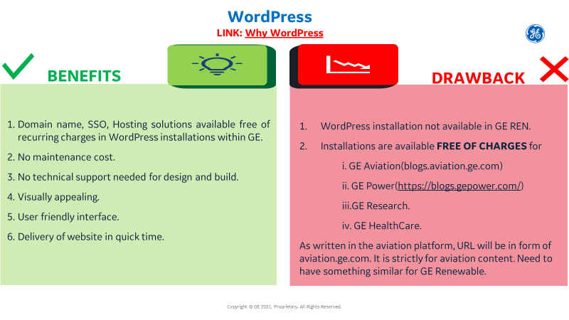

**DEMO WEBSITE FOR CASH AUTOMATION**

The website is made via WordPress. Website is currently in local host. This is a demo version and has tabs of HOME, DOCS, FAQ, CONTACT. The site is interactive and responsive at same time. User friendly and easy to maintain.

At full function, we expect 70-80 people using this. A weekly count of 20 unique people using it, is a considerable success.

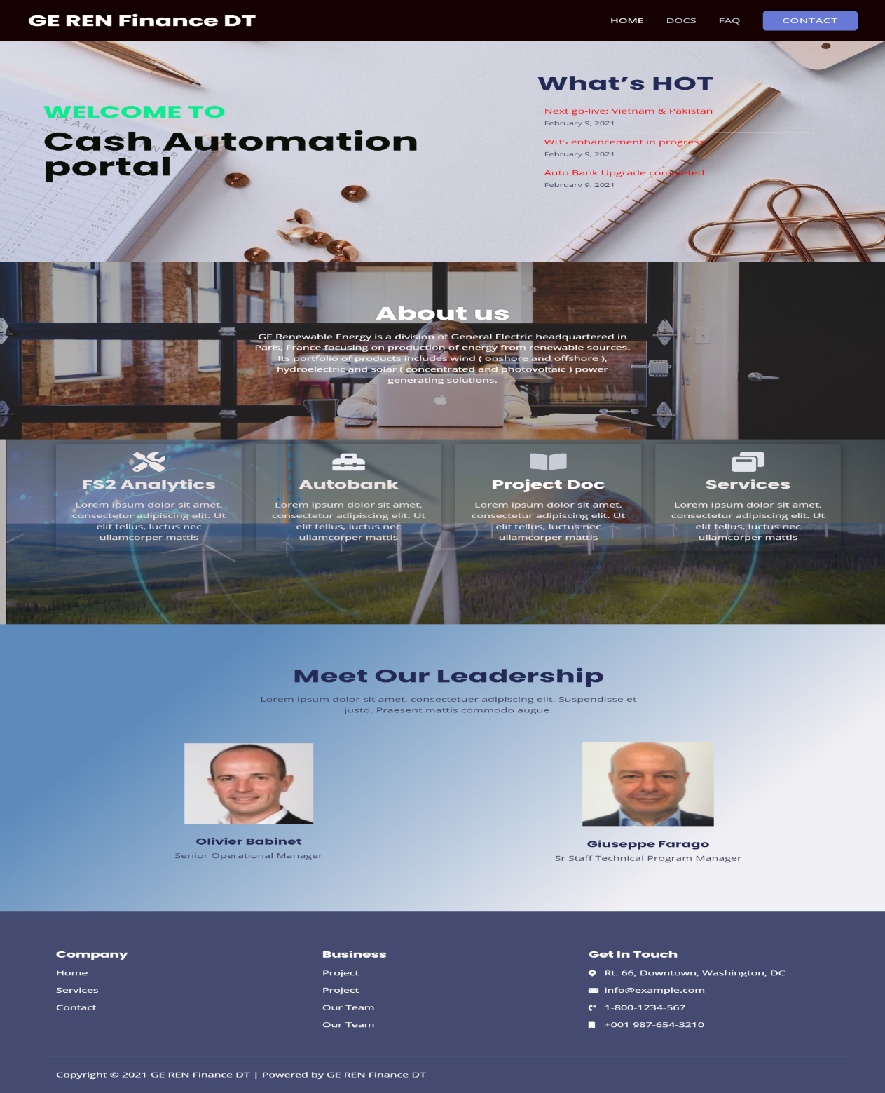

1. **BENCH** : is a GE tool for resource sharing. It is like Version Control System(GIT or GitHub). Good for collaboration among team members working on a project. Drawback is that it doesn’t give look and feel of website.

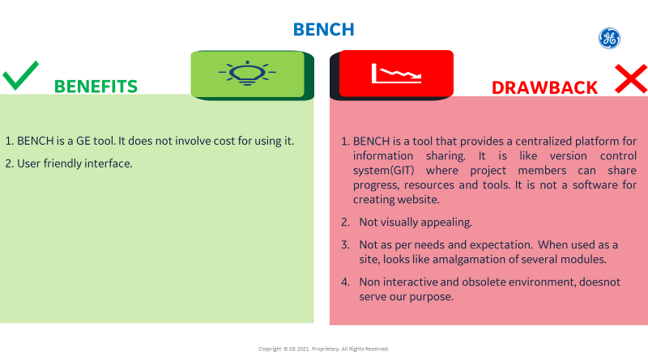

**BENCH FOR CASH AUTOMATION**

Links for Homepage, Yammer, Documentation, training, Forms and survey, Test. But as you see, the look and feel of it isn’t like a website. It isn’t attractive and not a place that people will come back for ease of use.

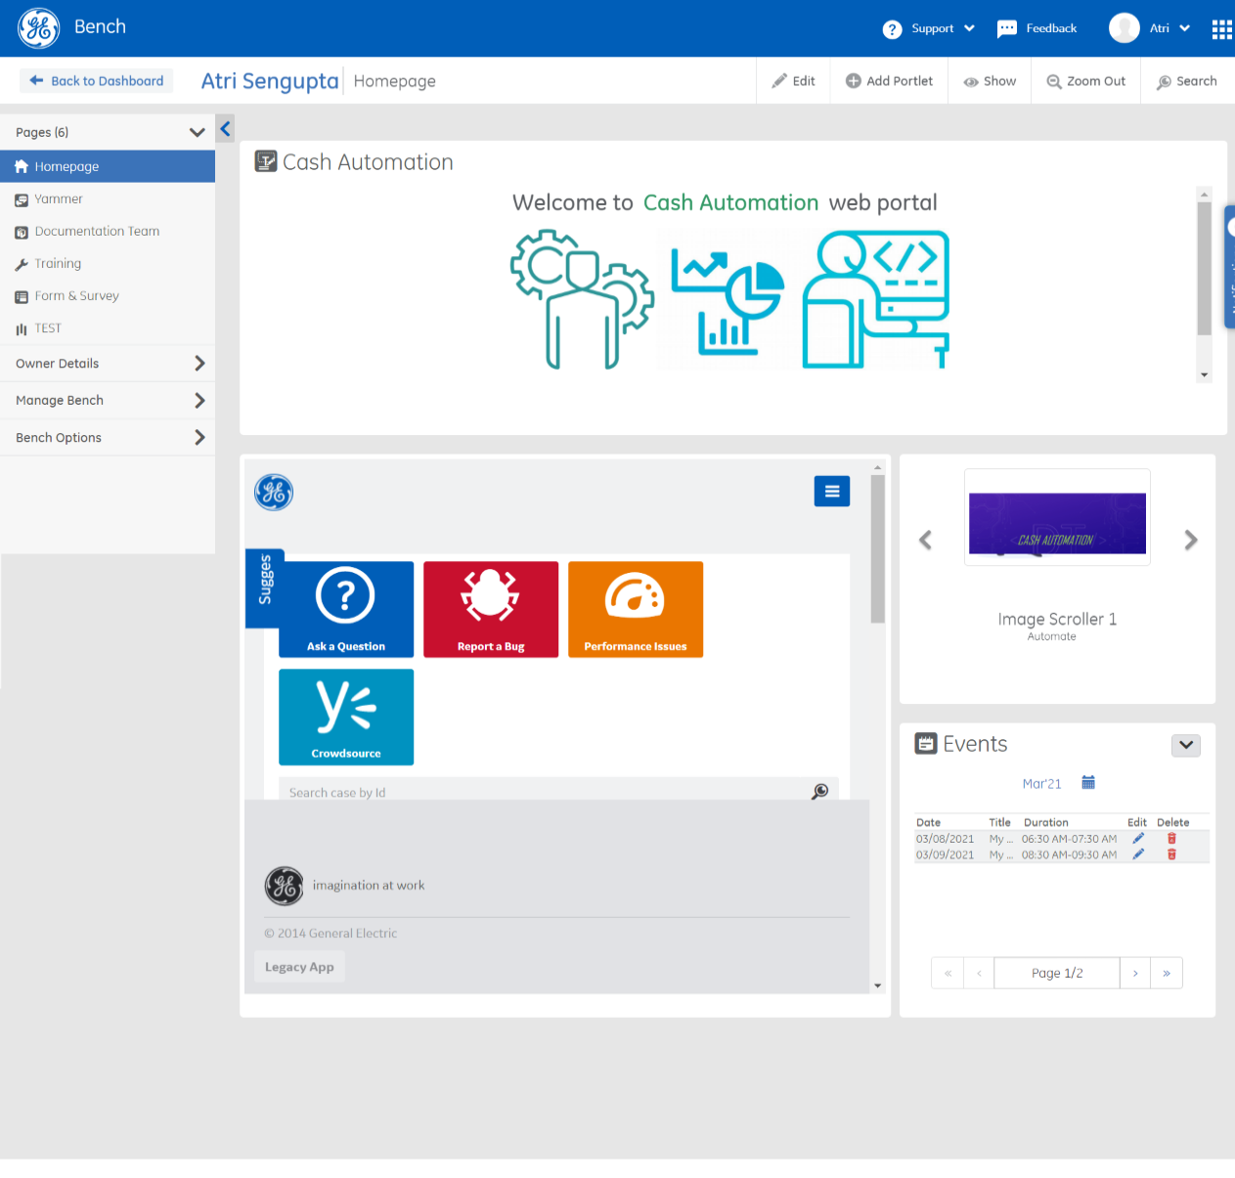

1. **Drupal** has been around for even longer than WordPress, though it lacks WordPress’ gaudy market share. Originally launched in 2000, Drupal powers 2.3% of all websites and has a 4.6% share of the content management system market.

Benefit of Drupal is this that it provides varied level of permissions for access to its webpages. Drawback: Forming the structure of a multi permission level website is complex. Plus maintenance gets difficult for the site owners. Site cannot be supported without having atleast minimum level of expertise in the skill set. Not user friendly.

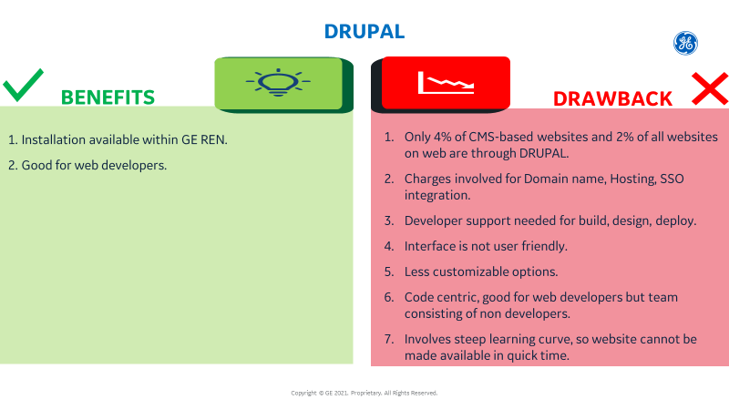

**Model Drupal site**

This is the Drupal site I have created. There is Home page and About page in menu. But underlying there are other pages as well which we can grant access only to site admins. I felt the structure to be complex and will be difficult to maintain. I completed the 4 Drupal 9 courses available in LinkedIn learning but still I do not have 100 percent confidence into it, the process being confusing.

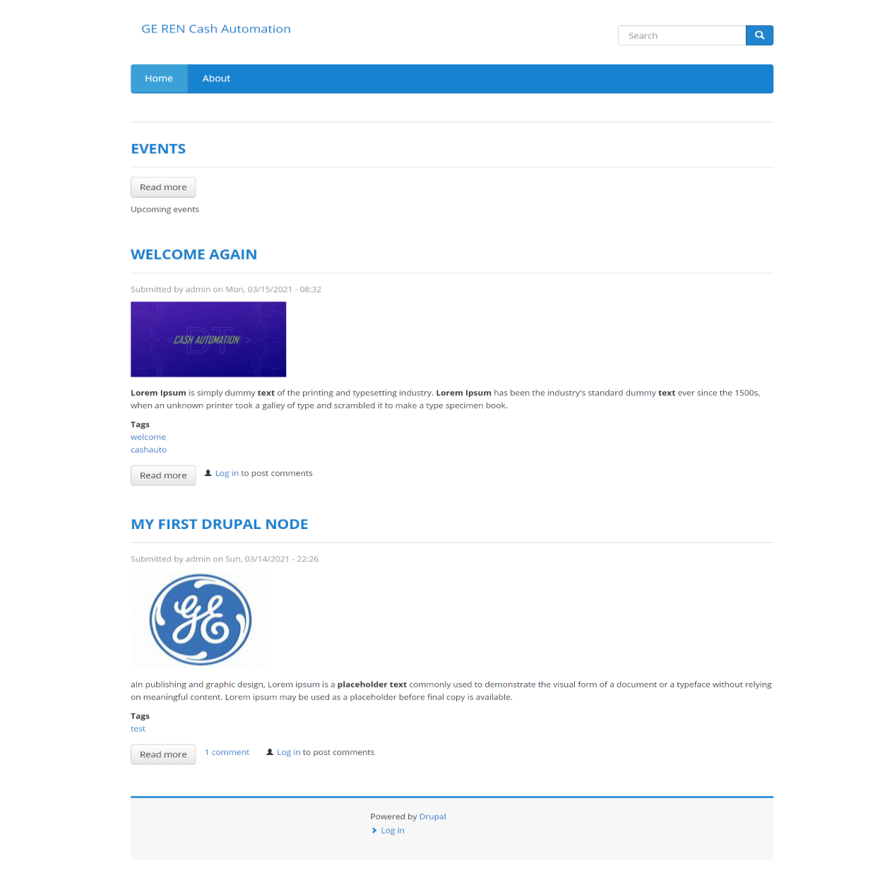

1. **SharePoint** is a web-based collaborative platform that integrates with Microsoft Office. Launched in 2001, SharePoint is primarily sold as a document management and storage system, but the product is highly configurable and usage varies substantially among organizations.

SharePoint provides in built SSO, hosting and GE domain name without any recurring charges. This solves the main issue that we had. Only drawback is that GE has moved from classic SharePoint sites to modern SharePoint sites which do not allow to customize the CSS.

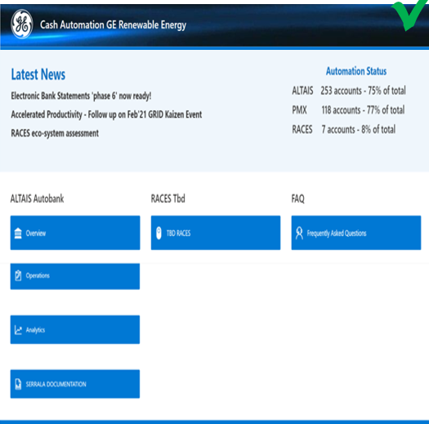

**2.1.6 CHALLENGES FACED**

1. GE has a complex structure, many teams and each team has its own way of doing things, own set of resources. There was no single ownership of solution across GE businesses.
2. No prior experience or documentation on what should be done if a functional team without developers need to have a website.
3. Budget limitations.
4. Needed to make sure that the tech stack used is such that the website can be maintained later on by the functional team without dependency of developers.

**2.1.7 LEARNING**

1. Early in the internship I learnt that a key skill in corporate would be to identify the right people in right time. For this I practiced networking. I dedicated time and effort to establish point of contacts not just in GE Renewable Energy but also beyond across GE businesses.

2. I had hands on experience on different web solutions. Starting from BENCH to WordPress to Drupal to SharePoint.

3. LinkedIn Learning courses in web solutions and learning about Lean, Pull, Kanban in GE website.



**Chapter 3**



**ERP Migration Project**

# 3.1 PROBLE STATEMENT

Need for a standard model which can be followed for GECARS-FDL projects under RACES. When the SIT was first piloted, the there was confusion in the team on steps that are needed to be followed, Steps were clear to some, maybe not to others and certainly not to people who do not have prior insight of the project.

This slowed down the entire process.

## OBJECTIVE

ERP migration project is a great opportunity to deploy the GECARS collection initiative at a time when we are shifting from CCL to RACES. Previous year we developed the application through FDL for RACES. But at that time the ERP project and the GECARS project was separate, there was a dedicated team to develop the solution for RACES. We decided when we will have SIT, UAT, Deployment. This time we are trying to deploy at the same time when ERP is moving.

## RESPONSIBILITIES ASSIGNED

I contributed to the initiative by creating a template for GECARS-FDL projects under RACES. I documented the technical steps needed to implement GECARS lite under RACES. This is like a generalized template and in future if there is change in ERP, then the same template can be followed with minimum changes in steps if needed.

**3.1.3 TARGET CUSTOMERS**

The target customers range from:

1. GECARS GENPACT TEAM.
2. CORP FINANCE DATA LAKE TEAM.
3. RACES ERP TEAM.
   * 1. **INTRODUCTION TO THE TEAMS**
4. **GENPACT TEAM:** Genpact began in 1997 as a unit within [General Electric](https://en.wikipedia.org/wiki/General_Electric). Its charter was to provide business process services to GE's businesses. During the eight years that followed, it began to manage a wide range of processes across GE's financial services and manufacturing businesses. In January 2005, the company became independent and began to serve clients outside of GE. The company name, Genpact, is designed to convey the business impact it generates for its clients. In August 2007, it was listed on the NYSE under the symbol 'G'. Since then the company has grown from 32,000 employees and revenue of US$823 million, to 77,000+ employees and revenues of US$2.57 billion (2016). In 2007, Genpact launched a joint venture with an Indian company [NDTV](https://en.wikipedia.org/wiki/NDTV) to offer outsourcing services for the media industry.[Bain Capital](https://en.wikipedia.org/wiki/Bain_Capital) became the firm's largest shareholder in October 2012.

GENPACT is in agreement with GE and provides manual services in the cash transaction process among other services.

**The GECARS collection initiative from GENPACT takes in open AR transactions from the FDL. It loads the payment and invoice details in its table. After this, along with NOVUS automation initiative it matches the open AR invoices with cash credit transactions and based on this it creates instruction file in form of BAI2. This BAI2 file is then sent to the ORACLE RACES ERP.**

1. **CORP FINANCE DATA LAKE TEAM**

Finance Data Lake is a data warehouse. GE wanted to have the data related to financial transactions for all its businesses in one single place. So that purpose is served by FDL. Several times in the day, whenever there is any financial transactions, the ERP of the business sends the data to FDL. So now whenever GE wants to look into the data and understand how the different businesses are performing it can go to FDL and look into it.

GE pays a considerable amount for FDL. So we at Finance DT try to make the maximum utilisation of FDL. Instead of creating an extra ERP field in the GECARS, we make use of FDL to act as the intermediate. FDL extracts all the open AR invoice and cash transaction details from the ERP and sends it to GECARS.

1. **RACES ERP TEAM**

**What is ERP?**

To put it simply ERP is an integrated software which takes care of the business transactions of different departments in an organisation. You need to have a basic understanding of how businesses work to understand how an ERP helps in any business.

Typically an ERP will have multiple modules like sales, purchase, inventory, finance, manufacturing, planning, payroll / HR. The entire flow of transactions of these modules are captured in an ERP and the data is seamlessly integrated between the modules.

So if you generate an invoice in the sales module, the required accounting entries are internally passed and available in the finance module and the inventory effect is visible in the inventory module. Same is the case for purchase and also for payroll. So if you book an invoice in purchase it will be visible in the finance module. Payroll processed will also have the required effects in the finance module. Any goods received through manufacturing will reflect in the inventory and show the respective effect in the books of accounts.

Based on the entries in finance from other modules, you can then proceed with payments against purchase invoices or to employees and also take in the receipts against sales invoices.

In earlier days, the modules as mentioned above, were stand alone and not connected to each other. This would involve multiple entries for the same transaction and was bound to have human errors and therefore there was the huge task of reconciliation. ERPs have done away with reconciliation requirements and there is only a single point of entry for any transaction and the effects are reflected in all the modules as may be required.

There are many other complications and business situations handled in ERPs, this is just a brief idea of what is an ERP. Today there are many cloud ERP solutions available which are easy to implement and use and most suitable for SMEs and organisations which are looking at a spurt in growth.

**How to Choose Best ERP Solution?**

Software Selection by industry: Requirements from company to company differ. Customers can’t select the same industry software.

* Scalability: Software ability to grow with your company
* Flexibility: Ability to meet your different requirements
* Excess Complexity: The less complexity the more user-friendly
* Best Technology: Technology should be user-friendly as per the current trend
* Cost: The total cost of ownership should be cost effective
* Best Culture: Software and software vendor should be culture friendly

**There are 3 ways in which ERP can be implemented in the Company**, they are

1. On-premise ERP

2. Cloud ERP

3. Hybrid ERP

On-premise ERP: In this method, the ERP solution is installed using your company's hardware and servers. Therefore investment is a little more on the expensive side as you have to pay for the hardware installations. An on-premise system requires your IT team to spend a significant amount of their time and budgets to ensure that your system is up-and-running when you need it, including maintenance of hardware, server rooms, and more. During the up-gradation of the ERP system, your IT team needs to re-implement various customizations and integrations that your business installed on your previous software.

Cloud ERP: The problem with on-premise [ERP solutions](https://www.tyasuite.com/erpsolutions) is that it can be only accessed when you are connected with the company server and that becomes problematic when you want to explore a solution from your home. And scaling is as easy as snapping your fingers (Thanos smiles in the background) you don't need the IT team to do it. It is highly secure as the vendors providing cloud ERP solutions provide a strong layer of security across the software. Another major complaint by companies regarding on-premise ERP is that the deployment time is way too high, cloud ERP can be implemented in any company within a few weeks.

Hybrid ERP: This is a conflux of on-premise ERP and cloud ERP

**Roles & Users**

Within those organizations, a number of job functions benefit from ERP, including but not limited to:

* Finance/accounting: The accounting team is often the first adopter. This group will track and report on all transactions and other financial information in the system, including accounts payable (AP), accounts receivable (AR) and payroll. With ERP, financial planning and analysis (FP&A) experts—whether a separate role or part of the accounting department—can turn comprehensive financial data into forecasts and reports on revenue, expenses and cash flow.
* Supply chain: Employees focused on operations, a group that includes purchasing agents, inventory planners, warehouse managers and senior supply chain leaders, rely on the ERP system to ensure a smooth and continuous flow of goods from supplier to customer. They count on accurate, detailed information provided by the system to optimize inventory levels, prioritize orders, maximize on-time shipments, avoid supply chain disruptions and identify inefficient processes.
* Sales and marketing: An ERP solution can increase the productivity of and drive better results for your sales team by automating lead management and monitoring the interactions prospects have with your company. Reps can document discussions and change the status of prospects as they move through the sales funnel. Using those same records, marketing can automate and manage outreach across all channels, from email to display ads to social media, and measure the effectiveness of those messages and channels to better allocate its budget.
* Human resources: The HR department tracks all employee information and broader workforce trends in the ERP. It can quickly find contact information, compensation and benefits details and other documents for each employee. HR can also monitor metrics like retention by department, average pay by title, promotion rate and other metrics to better allocate its own staff and assist line-of-business managers.

**Benefits of ERP Software**

1. **Competitive Advantage**: It’s true that ERP software requires a major investment, but there’s also an even bigger cost in not making the investment. While some manufacturers choose to stick to the tried and true methods of the past, others seek technology solutions. With so many enterprise resource planning advantages the software provides, users can see improvements within multiple departments.
2. **Improved Process Efficiency**: An ERP platform eliminates repetitive processes and greatly reduces the need to manually enter information, which not only improves user productivity but eliminates the possibility of inaccurate data which could lead to making costly business mistakes.
3. **Accurate Forecasting**: Enterprise resource planning software gives your users, and especially managers, the tools they need to create more accurate forecasts. This helps software users, and businesses as a whole, think ahead and properly plan what they need from inventory and sales down to financials and customer service.
4. **Department Collaboration**: Nobody wants to run a siloed business with each department functioning separately from the other. Collaboration between departments is a crucial and often necessary part of the business, especially because business projects often involve more than just one department.
5. **Scalable Resource**: Structured ERP systems allow the addition of new users and functions to grow the initially implemented solution over time. No matter how big or small your business is ERP grows with it, being able to occupancy new users and new rounds of data whenever your business is ready to expand.
6. **Integrated Information**: Enterprise resource planning software acts as a central hub for all of the important information that your business and the departments within it need to maintain daily business practices and operations. No more issues with data spread across separate databases; all information will be housed in a single location.
7. **Cost Savings**: With every business, you want to be smart with your financials and avoid making costly mistakes that could hurt your business in the end. With one source of accurate, real-time information, enterprise resource planning software reduces administrative and operations costs, allows businesses to utilize money in other, much-needed areas.
8. **Streamlined Processes**: As manufacturers grow, their operations become more and more complex, which unfortunately increases the opportunity for costly mistakes to be made. Manufacturing software automates business operations cross-departmentally, providing accurate, real-time information to everyone utilizing the solution, all while eliminating manual duty, which often has the potential to lead to errors.

**PROCESS MAP FOR THE PROJECT**

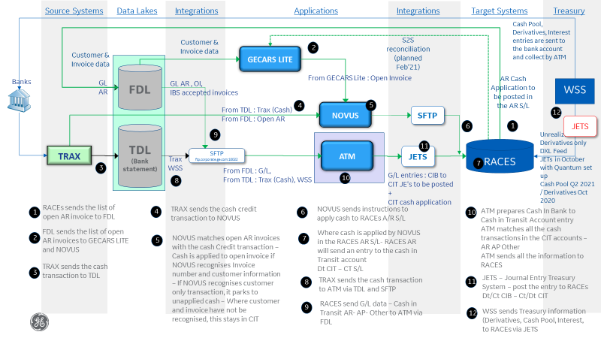

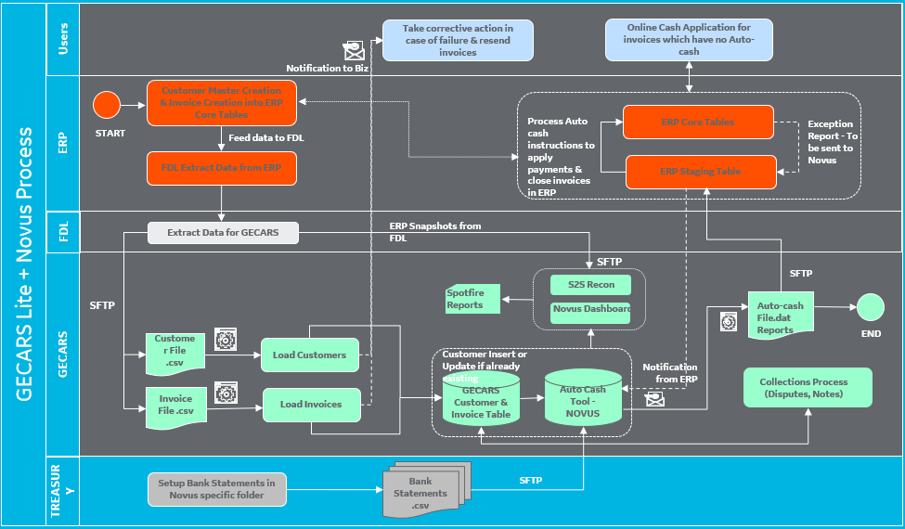

**STEPS INVOLVED**

1. FDL Extracts data from Races.
2. FDL program sends data to GECARS in GECARS requested format through SFTP.
3. GECARS batch program loads data into GECARS tables for further processing.
4. TRAX sends bank statements into GECARS through SFTP.
5. GECARS loads bank statements into GECARS Payment/Cheque tables for further processing.
6. GECARS Novus program prepares a BAI2 file matching payments to invoices based on data in GECARS.
7. GECARS batch program will send the BAI2 file containing auto-cash instructions to ERP through SFTP.
8. ERP retrieves the BAI2 file and applies payments to invoices based on the auto cash instructions.
   * 1. **BUSINESS OUTCOME**

Now that the template is ready, the target customers know that okay, I need to implement GECARS, I need to follow these 80 steps in the given order. The plan simplified the process, made the it error proof. This increased the productivity and speeded up the process.

* + 1. **TECH STACK USED**

1. **Smartsheet:** It is a software as a service offering for collaboration and work management, developed and marketed by Smartsheet Inc. It is used to assign tasks, track project progress, manage calendars, share documents, and manage other work, using a tabular user interface.
2. **MS Excel:** Microsoft Excel is a spreadsheet developed by Microsoft for Windows, macOS, Android and iOS. It features calculation, graphing tools, pivot tables, and a macro programming language called Visual Basic for Applications.
   * 1. **CHALLENGES FACED**
3. Talks started between GE and Genpact on future of automation and eventually 2 automation initiatives went out of scope. So there was a brief hold on the project.
4. Coming from a non-Finance, not IT background, I didn’t have any insight on Finance or experience of working on IT project. Initially when SIT was going on I struggled to understand the steps involved. But thanks to my mentor, my team, eventually I started understanding and came to pace with the project. Now I have good insight into the processes involved. I know the function of each of the three teams working on the project.
   * 1. **LEARNING**
5. I understood how two corporates GE and GENPACT work together, the shared services and the relation between them.
6. Since this project involved multiple teams, I understood how a multi team project functions.

**DRAFT FOR TEMPLATE OF GECARS PROJECTS UNDER RACES**

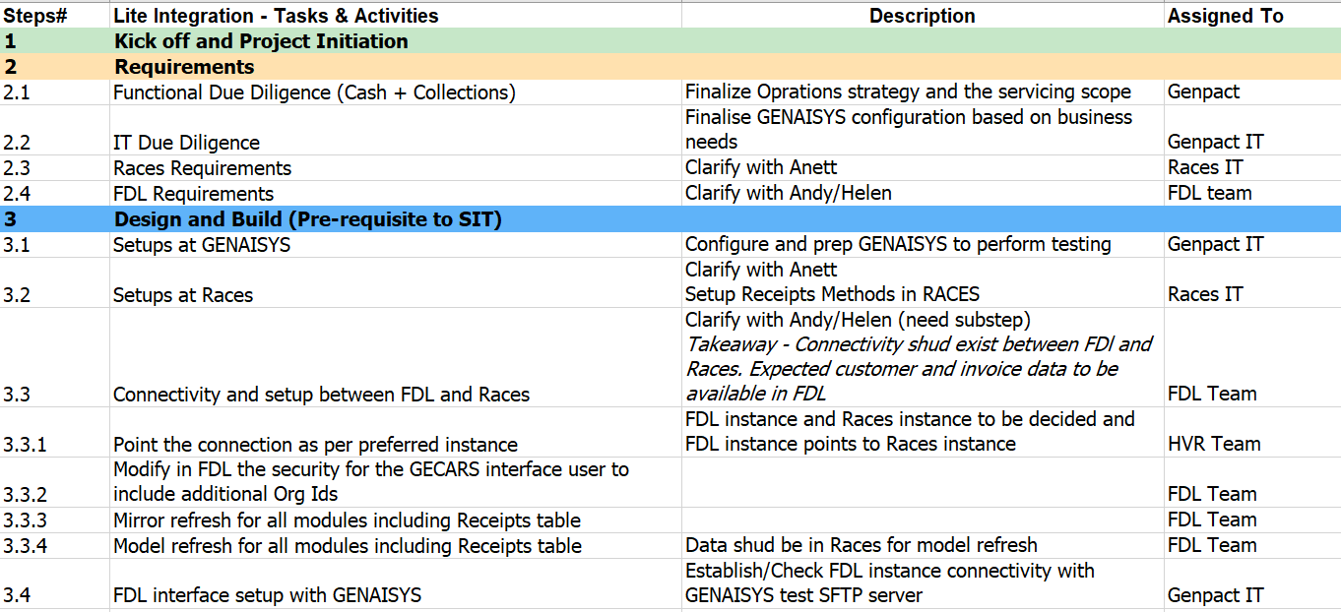

**KAIZEN EVENT**

**Aim:**

The purpose is not to see how to automate the entire cash transaction process but to find the defects in the sections that are already automated and find why the automation rate is 40 percent, see how to remove the defects and if the defects are removed then what will be the percentage of automation. The desired rate of automation should be atleast 70 %, only then the cost GE pays to acquire the license of Autobank will make sense to continue further.

Focus is on the Altais bank accounts serviced by GENPACT(90% of the bank accounts).

At present the automation rate is 100% in GL, 40% in SL and 20% in Account rec.

The purpose of the Kaizen event is to bring 100% automation at SL level .i.e all transaction in bank statement posted in SL should be automatic.(By posting I mean applying the payment to the invoice at SL level). Any manual posting in SL will be considered as defect.

**On first day** we formed the template, consisting of **type of defect(conversion table, bank statement extraction, remittance extraction, invoice clearance), the defect description, reason behind the defect, solution, ownership, impact, effort needed** among other columns.

We listed 2 defect which were related to **“Conversion table”,** understood the defect and the reason behind it, as well as how to solve the issue.

**On the next 2nd day** we listed the rest of the defects, understood what the defect is and reason.

**On the 3rd day** we listed the solution of all the listed defects, who will be responsible, who to take consultancy from.

**On the final day**, we listed down the time taken t solve each issue, the degree of impact of it after it is solved and degree of effort that needs to be put.

At the end it was understood that if in ideal case all actions to remove defects fall in place, then the rate of automation will shoot up to 70%, but that is in a perfect world; there will be actions, some will work as expected whereas some wont. So the time taken in true sense is more than 4 months .i.e beyond June.

**Gist of defects**

**Conversion table**

Name to number conversion not available in conversion table. Customer identification not possible by autobank. The reason behind is that New customer or customer with different bank account or customer changed bank narration

**Bank statement extraction**

1. VAT, GST, expenses not included in the bank description so payment cannot be applied automatically. Reason is that customer didn’t include in bank narration and bank doesn’t provide the info.
2. Incomplete bank statement or unreadable. Reason is:
   1. Incorrect invoice.
   2. Special characters.
   3. Chinese characters.
   4. Character limitation of 360.

Educate customers on the format.

1. Bank sends files to webcash which donot convert Chinese to English very well. Reason behind is that in china customers send remittance in Chinese which get converted to English in TRAX. This conversion is not perfect and customer identification possible in Chinese but not in english.
   1. Investigate Chinese character in altais and autobank.

**Remittance extraction**

1. Remittance not provided or provided after payment is made. Reason is this that customers send remittance to wrong location, they donot know the format and location in which remittance needs to be send. Educate customers how to send remittance.
2. Incomplete remittance or unreadable. Reason is:
3. Special character.
4. Chinese character.
5. Abbreviation.
6. Incorrect invoice number.

Technical fixes in OCR will solve the issue.

1. OCR doesn’t recognise remittance to multiple invoice payment.

Total payment or net payment needs to be mentioned for the OCR to recognise.

1. Remittance information not followed by rule due to deduction of bank charge from total payment made. OCR recognises by total payment and not by customer name.

**Clearing invoice**

1. Payment cannot be made to multiple bank account The customer name to number conversion only applicable to payment made to single account. In conversion table only 1 customer name to customer number linking is possible.
2. Autobank not able to read partial invoice number
3. Autobank doesn’t support under payment. All underpayment needs to be don’t manually.
4. Customer sending payment to wrong bank account. Bank account changed but not updated in system.
5. Invoice number has other number and characters within it due to which autobank cannot recognise invoice number.

**KAIZEN DETAILS TABLE SNAP**

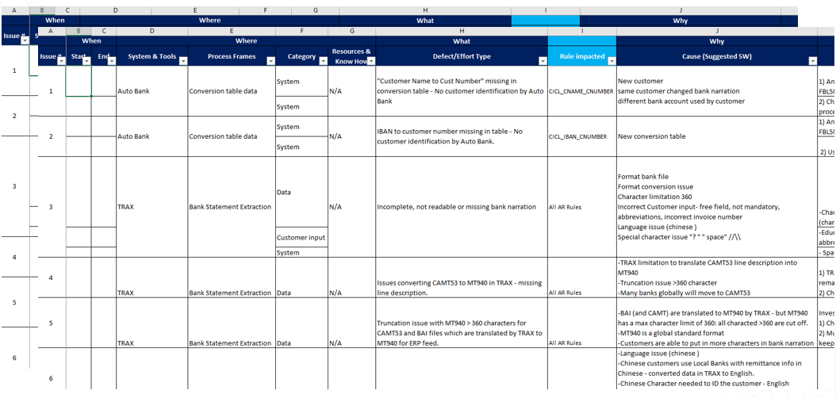

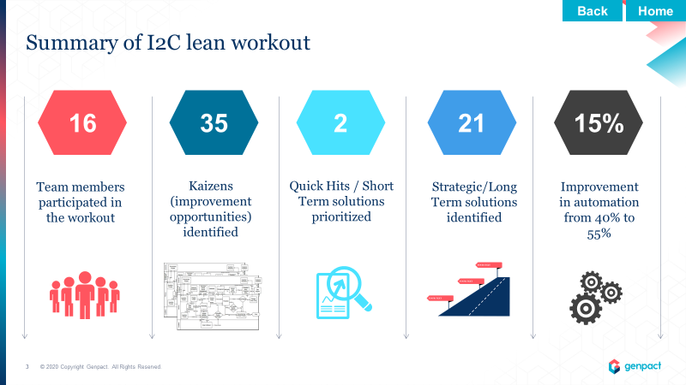

.

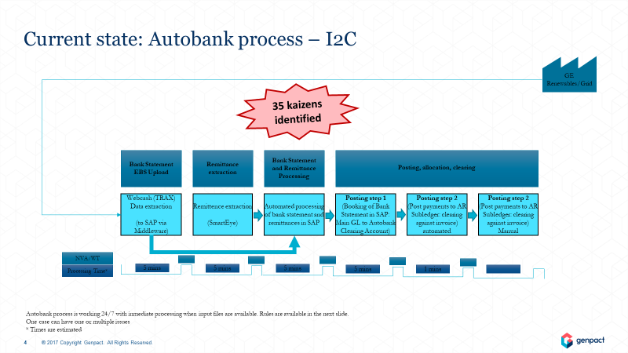

# Chapter 4: Schedule, Tasks and Milestones

Internship started with one week insight on Finance.

For the cash automation website, we agreed upon sharepoint as the solution that best suit our requirements. Design and build phase is over. Currently we were testing with the key users and we will deploy the website in this month.

For the ERP migration project, SIT and UAT plan is ready and detailed. We have sent it to the stake holders for their updates.



**Chapter 5: Conclusion**



During this project I got to work In a startup like environment and came across a steep learning curve which helped me grow and develop. The website has caused significant reduction in cycle time and saved money as well as positive effect on cash flow impact. Besides this I got to work in ERP migration projects, that was a great learning experience as well. What in my regards makes GE special is the fact that seniors irrespective of the position they hold in the organization, irrespective of years of experience were so open to conversations. That is something what I could never have imagined getting an opportunity like when I was in university some months back. I tried to absorb as much learning as I could from them. The Inputs I got from them is invaluable. Its something which I could work on not just now but also adapt in future, grow and develop from it. The internship in GE was a great experience and certainly ticked all checkboxes of a dream internship.

